Shepeau Stow Primary School
KS1 Knowledge Organiser- Spring Term 2021
Boudicca

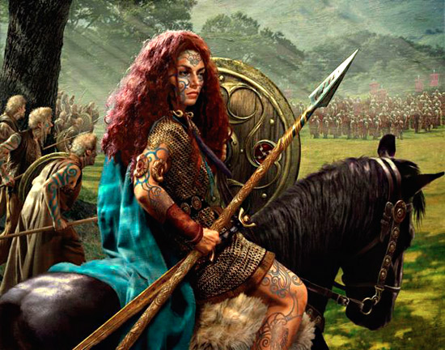
Boudicca was a Celtic Queen and a member of the Iceni tribe who lived in Norfolk. She was married to King Prasutagus and they had two daughters. Sadly, in 59 AD, Boudicca’s husband died. As a woman she had no right to inherit her husband’s property. Prasutagus hoped to protect Boudicca by leaving half of his property to the Emperor Nero. However, the Emperor decided to take all of her property. Boudicca joined forces with the neighbouring tribe of the Trinovantes and led a rebellion against the Romans. Although she successfully won her first few battles, her people were defeated at the Battle of Watling Street in 61 AD.

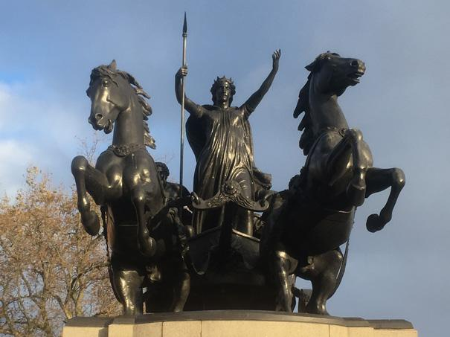
Born: 30 AD, Britannia
Death: 61 AD, Britannia
Key Vocabulary:
AD | Anno Domini: a Latin phrase meaning "in the year of the Lord", which is used when referring to a year after Jesus Christ was born
inherit | to be given a persons money or property when they die
rebellion | a violent act organised by a group of people
defeated | to lose a battle

Useful online links:
BBC Bitesize | https://www.bbc.co.uk/bitesize/topics/zkrkscw/articles/zhn6cqt

Bronze sculpture of Boudicca- Westminster Bridge, London

