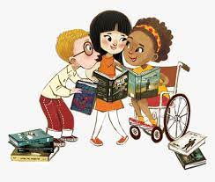
Breaking news!
Our new library is now up and running. There is an amazing collection of exciting and up to date stories, as well as a fantastic range non-fiction books, for all of our children to enjoy.
We would like to invite you to come with your child / children to the library to share and take books out on loan.
As space is limited in the library, we will start with a timetable of opening times for each class. If you have children in more than one class, please come with them on the date scheduled for the oldest sibling. This may be revisited depending on demand.
The library will also be used for Storytime Club on Thursday lunchtimes, open at playtimes to the children, and used for a host of other school-time activities.
We are looking forward to seeing you on Thursdays after school and hope you will enjoy sharing our marvellous new books!
Mrs Barmby
Gedney Hill Library After School Opening Times
Class | Date | Time
Swallows | Thursday 10 March | 3.20pm – 4.15pm
Kingfishers | Thursday 17 March | 3.20pm – 4.15pm
Robins | *Friday 25 March | 3.20pm – 4.15pm
Swallows | Thursday 21 March | 3.20pm – 4.15pm
Kingfishers | Thursday 28 March | 3.20pm – 4.15pm
Robins | Thursday 5 May | 3.20pm – 4.15pm

